Case 9-MEX-Nayarit-Female Figure-Holding Maize Bread Offering-500 CE
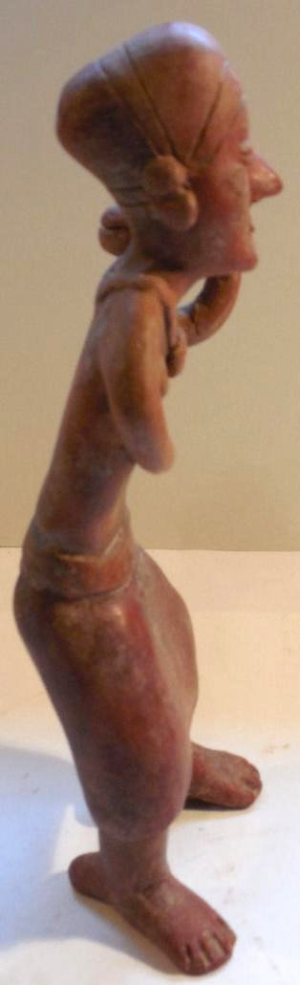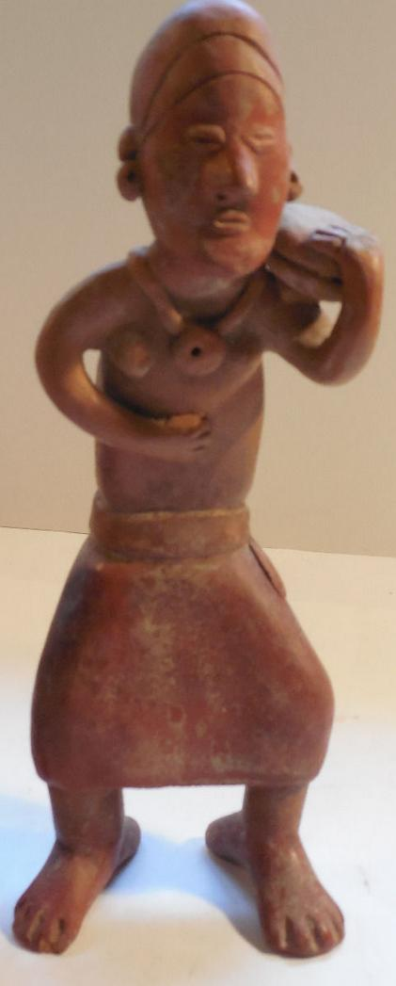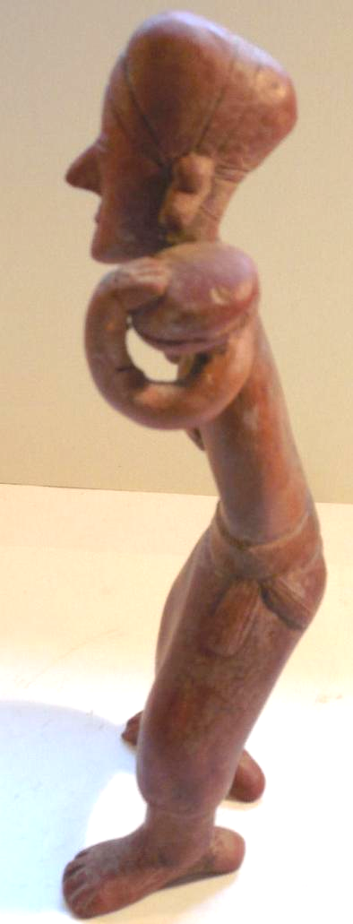
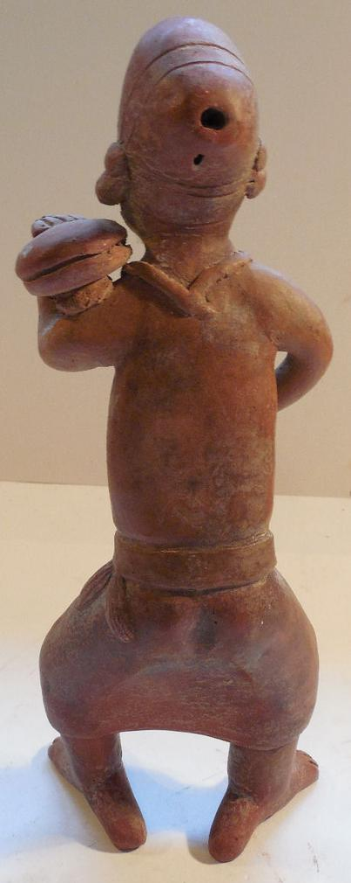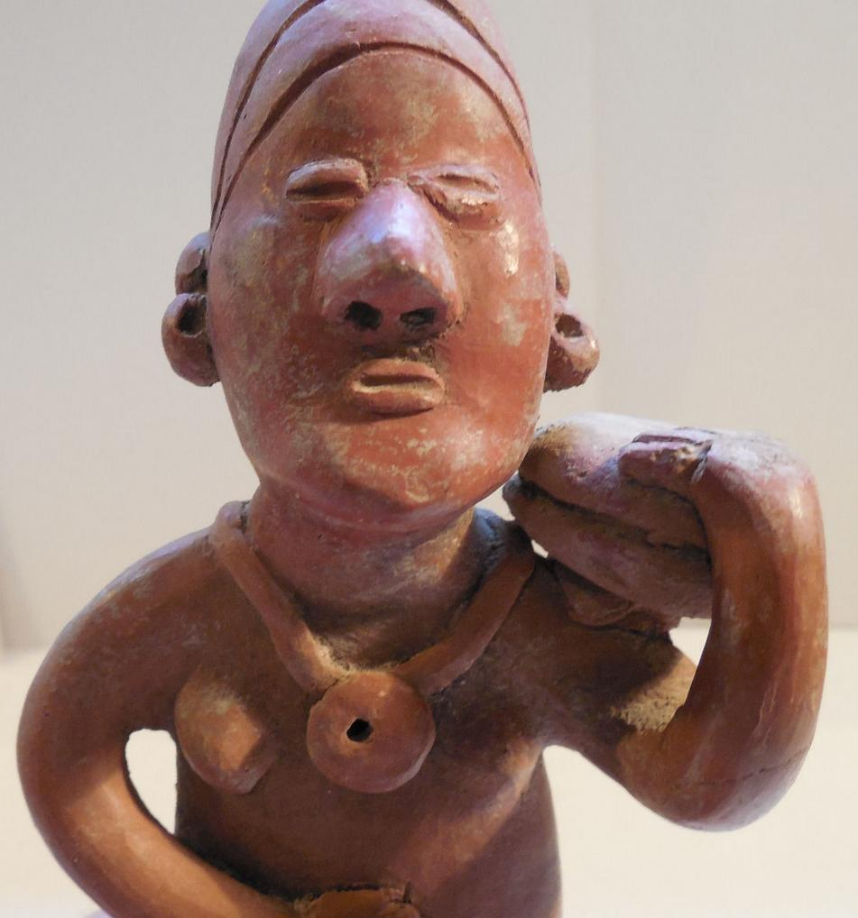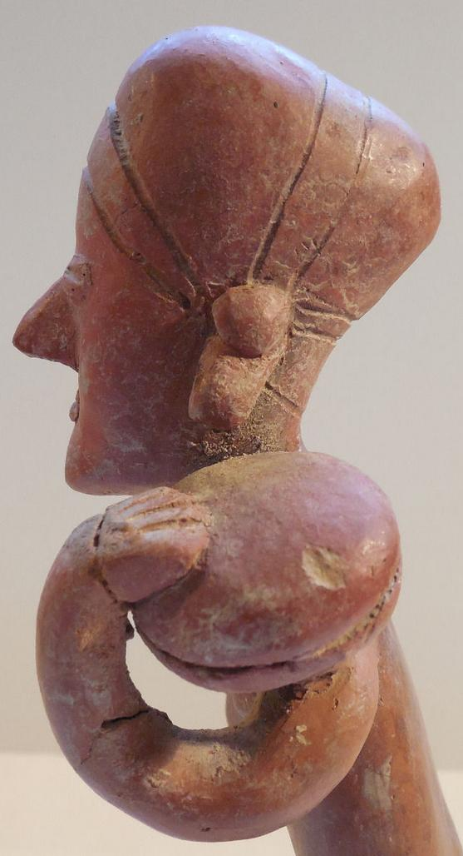

Case No.: 10
Accession Number:
Formal Label: MEX-Nayarit-Female Figure-Holding Maize Bread Offering
Display Description:
Nayarit female figure with a red slip has a headdress or hat, ear spools, a necklace, and a skirt which is still packed with ancient dirt from when it was excavated. She is holding an offering of maize bread on her shoulder.
LC Classification:
Date or Time Horizon: 500 CE
Geographical Area: Nayarit, Mexico
Map:
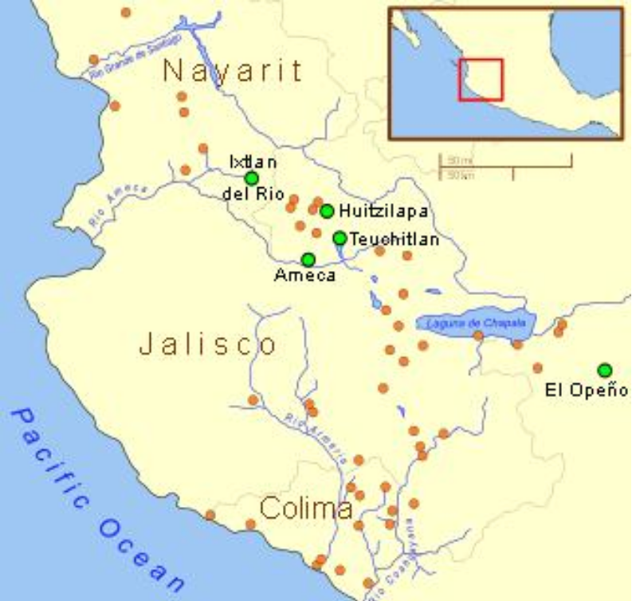Shaft tomb burials in West Mexico. After https://upload.wikimedia.org/wikipedia/commons/thumb/d/d3/Ancient_Western_Mexico_Archaeological_Sites.svg/350px-Ancient_Western_Mexico_Archaeological_Sites.svg.png
GPS Coordinates:
Cultural Affiliation:
Medium: terra cotta with red slip
Dimensions:
Weight:
Provenance:
Condition: The arm to the shoulder was repaired at some point, but isn't noticeable.
Discussion:
The Western Mexico shaft tomb tradition or shaft tomb culture refers to a set of interlocked cultural traits found in the western Mexican states of Jalisco, Nayarit, and, to a lesser extent, Colima to its south. Built beneath house platforms, these tombs served as family mausoleums and were periodically opened to inter the recently deceased. This ceramic figure is a fine representation of the Nayarit style known as Chinesco, notable for smooth burnished surfaces and painted slip and for the slit-type eyes.
References:

Appendix:

Order details

Sales order
Sold by bobski117 ( 2813 )

Delivery package 1 of 1
Estimated delivery Thursday, Dec 31, 2015 - Tuesday, Jan 5, 2016
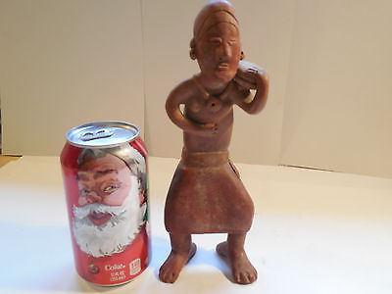

Large Nayarit Woman Shaft Tomb Pre-Columbian Ancient Artifact Colima Aztec Mayan
Item price | $177.50
Quantity | 1
Item number | 121846040301
Shipping service | USPS Priority Mail

